Path Correction Solutions: Vision vs Control
Oct 27, 2026 · @Rasitha R

The big picture
Five solutions fix the heading error between sensing and actuation on curves. Most of them live in Control; Vision supplies clean, timestamped edge data and helps reject wrong features.
The system has three software components plus the robot program:
- Vision: Gocator profiles in, edge points out.
- Control: decides what the robot does with the edge data, and when.
- Connectivity (RTDE): robot pose and time to Control, offsets to the robot.
- Robot program and hardware: nominal path, speed, lead distance L, Gocator field of view.
The simple rule: Vision answers "what do I see and where is it?" Control answers "what should the robot do with it, and when?"
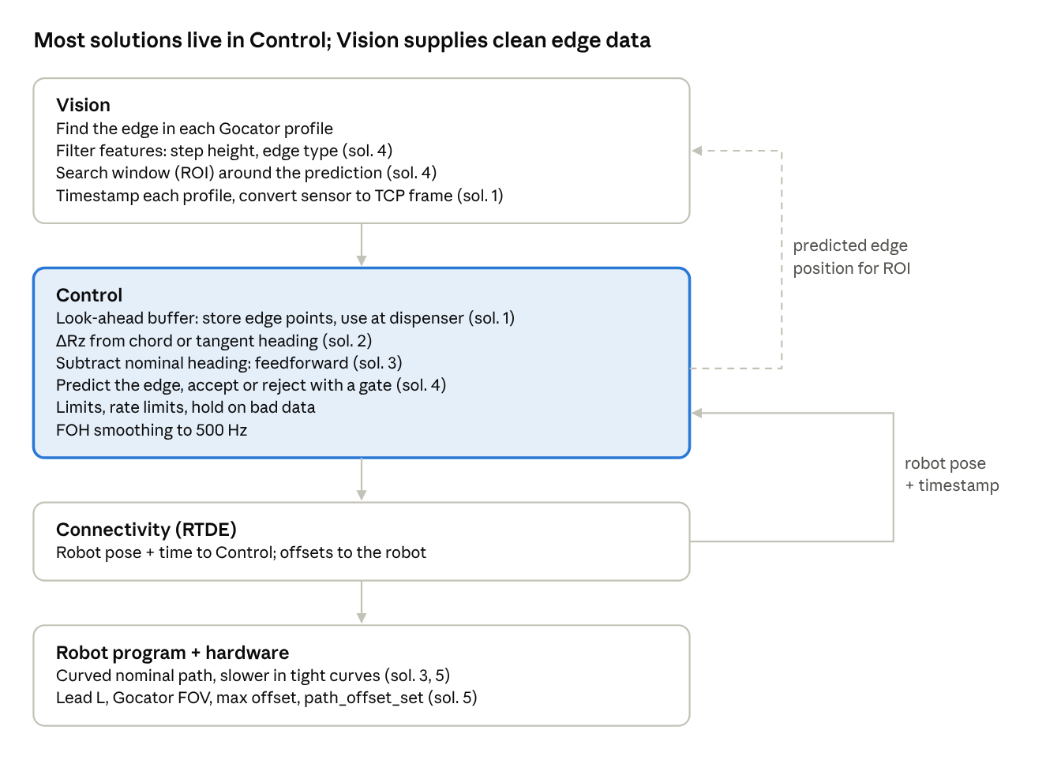
Which solution lives in which component
Data flows down from Vision to the robot; Control sends the predicted edge back to Vision, and Connectivity returns the timestamped robot pose to Control.

Solution 1: Look-ahead buffer (Control)
Store each sensed edge point and use it only when the dispenser reaches that spot. This removes the L²/2R lateral error on curves.
Problem: the Gocator looks at a spot L ahead of the dispenser. Correcting immediately with that reading uses information about a spot the dispenser has not reached yet.
Everyday comparison: driving at night, your headlights show a pothole 20 m ahead. You don't swerve now. You remember where it is and steer when your wheel gets there.
How it works:
- Vision finds the edge in the profile, converts it to the TCP frame, and adds the capture time (for example t = 10.000 s).
- Control looks up where the robot was at t = 10.000 s, interpolating the timestamped RTDE poses.
- Control combines the two into an edge point in base coordinates, fixed to the world, and stores it in the buffer.
- Every 2 ms, Control finds the stored point at the dispenser's current position along the path and calculates ΔX, ΔY, ΔZ from it.
- Points behind the dispenser are deleted.
Example buffer:
# | Position along path (mm) | Edge X (mm) | Edge Y (mm) | Edge Z (mm)
1 | 100.0 | 501.5 | 200.0 | 95.8
2 | 101.0 | 501.6 | 201.0 | 95.8
Requirements:
- Accurate timestamps: the robot pose at the exact moment of each profile.
- A short pre-scan: start scanning at least L before the bead starts.
- Look-up by position, not by time, so speed changes on curves don't matter.
Why Control: it needs both the Vision data and the robot pose, and it decides when to use the data. Vision only supplies the point and an accurate timestamp.

Solution 2: Aiming Rz correctly (Control)
Turn the tool so the Gocator keeps looking at the edge through the curve. For a round nozzle, aim along the chord; for a shaped nozzle, along the tangent.
Problem: on a curve, if the tool keeps pointing straight ahead, the Gocator (L ahead) looks off to the side and can lose the edge.
Everyday comparison: on a bend, you turn your head toward where the road is going, not straight ahead.
How it works:
- From the buffer, Control knows where the edge is under the dispenser and where it is L ahead.
- Control chooses the heading:
  - Round nozzle → chord: point the tool at the edge point L ahead. The laser stays centred; the bead doesn't care about Rz.
  - Shaped nozzle → tangent: point the tool along the edge direction under the dispenser. Check that the sag L²/2R fits inside the field of view.
- ΔRz = chosen heading − current nominal heading.
The angle between chord and tangent is about L/2R. Rotate about the dispenser tip (path offset type 2, TCP at the nozzle), so the dispenser stays put and only the Gocator swings.
Why Control: it's a decision based on the buffer. Vision provides the edge points it uses.

Solution 3: Let the nominal path do most of the turning (Control + robot program)
The curved nominal path already turns the tool; ΔRz only adds the small difference between the nominal and the real edge.
Problem: if ΔRz has to provide the whole turn of a curve, corrections are big and fast, and big corrections swing the Gocator.
Everyday comparison: a train follows the curved rails by itself. You only lean a little to keep your balance; you don't steer the train.
How it works:
- The robot program (nominal path) already curves, so the tool turns by itself.
- Control adds only the difference: ΔRz = real edge heading − nominal heading, usually a few degrees.
- Control gets the nominal pose as actual pose ∘ inverse(current offset), both from Connectivity.
- If ΔRz is often large, the nominal path is too far off: re-teach it or add waypoints in tight curves.
Where: the nominal path is in the robot program; the subtraction is in Control.

Solution 4: Predict the edge and ignore surprises (Control + Vision)
Control predicts where the edge should appear and rejects detections far from it; Vision filters features and searches only near the prediction. Together they stop the robot locking onto a wrong feature.
Problem: nearby features (a lower step, a second edge, a hole) can be mistaken for the real edge.
Everyday comparison: following a friend in a crowd, you look where they should be, not at the first person who looks similar.
In Control (prediction and gate):
- Fit a short line or arc through the latest buffer points to predict where the edge will appear on the next laser line, for example at +0.8 mm.
- Check each reported edge against the prediction, for example within ±3 mm:
  - inside the gate → accept and store it in the buffer;
  - outside → reject, use the prediction, and count the rejection.
- Too many rejections in a row (for example 10) → stop dispensing and raise an alarm.
In Vision (filtering and narrowing):
- Feature filter: accept only edges that look like the right one, for example a step up of about 2 mm, not a step down, or a minimum edge sharpness. The Gocator's built-in profile tools can do this.
- Narrow search window (ROI): Control sends the predicted position back, and Vision searches only near it.
- Report quality: send a valid flag and a confidence value, or several candidate edges, so Control can choose.
Vision says "these are the edges I see, and how sure I am." Control says "this one matches what I expected, so I'll use it."

Solution 5: Design limits (robot program + hardware)
These are design choices, not software calculations. They set how tight a curve the system can follow.
Choice | Where | Why
Lead distance L | Mechanical mounting | Shorter L gives a smaller curve error (L/R, L²/2R) but less time to react
Gocator field of view | Sensor choice and standoff | Wider FOV means the edge is lost less often in curves
Slower speed in tight curves | Robot program (nominal path) | More samples per mm and gentler corrections
Max offset and alpha filter | Robot program (URScript) | Last safety net if something goes wrong
Rule of thumb: the tightest curve radius should be bigger than about L² / FOV. For example, L = 50 mm and FOV = 20 mm gives R ≥ 125 mm. The chord heading from solution 2 allows tighter curves.
R_{min} \approx \frac{L^2}{FOV}

Summary and build order
Build in the order 1 → 4 → 2 → 3 → 5 (tuning): the buffer fixes the main error, and the gate makes it safe.
Solution | Problem it solves | Vision | Control | Robot / hardware
1. Look-ahead buffer | Reading applied in the wrong place | Edge point + exact timestamp | Store, look up at dispenser | Pose + time via Connectivity
2. Rz aiming | Laser leaves the edge in curves | — | Chord or tangent heading | Rotate about nozzle tip (type 2)
3. Nominal feedforward | Big, fast ΔRz | — | ΔRz = real − nominal | Curved nominal path
4. Prediction + gate | Wrong feature picked | Feature filter, ROI, quality | Predict, accept or reject, alarm | —
5. Design limits | Physics limits | Field of view | — | L, speed, max offset
Per 2 ms cycle, the combined result:
ΔX, ΔY, ΔZ ← stored edge point under the dispenser
ΔRz ← chord (round nozzle) or tangent (shaped) − nominal heading
limit + rate-limit all four, hold on rejected or invalid data
path_offset_set([ΔX, ΔY, ΔZ, 0, 0, ΔRz], 2)

